<Google Classroom>

**Online Learning Platform**

Use-Case Specification: <View Schedule>

Version <1.1>

Revision History

| **Date** | **Version** | **Description** | **Author** |
| --- | --- | --- | --- |
| 05/12/2021 | 1.0 | Initial version | Le Hong Hai |
| 09/12/2021 | 1.1 | Edited version | Le Hong Hai |
|  |  |  |  |
|  |  |  |  |

Table of Contents

1. Use-Case Name 3

1.1 Brief Description 3

2. Flow of Events 3

2.1 Basic Flow 3

2.2 Alternative Flows 3

2.2.1 < First Alternative Flow > 3

2.2.2 < Second Alternative Flow > 3

3. Special Requirements 3

3.1 < First Special Requirement > 3

4. Preconditions 3

4.1 < Precondition One > 3

5. Postconditions 3

5.1 < Postcondition One > 3

6. Extension Points 3

6.1 <Name of Extension Point> 3

Use-Case Specification: <View Schedule>

# Use-Case Name

## Brief Description

-This process for user to view Schedule in Google Classroom

- For who: users

- The purpose: helping users to know time and to-do-lists in every class they’ve taken part in

# Flow of Events

## Basic Flow

First, at the top left, move mouse pointer to Menu icon (icon ) (when hovering over this icon, the mouse pointer will turn into a pointing hand icon, it will appear as a tooltip like a small box named “Main Menu '' with text color: white and background-color: black. Also, the menu icon background will be blurred a little bit with a gray circle around it).

Then, when clicking 1 time in this Menu icon (), Menu icon disappeared and a selection panel (background-color: white) will be displayed in left-side (including “Classes” with icon like a house in the left-side of “Classes” text, “Calendar”- under “Classes” with icon calendar in the left-side of “Calendar” text, “Enrolled” with “To-do” with notebook icon in the left-side of “To-do” text, user’s classes with different color cycle icon in the left-side of class’s name , “Archived classes” with save icon in the left-side of it and “Settings” with bolts icon in left-side of it respectively). Text-color in this selection panel is black.

When hovering the mouse pointer in the “Calendar” part (with icon calendar in left and text “Calendar” beside), the mouse pointer will turn into a pointing hand icon with text color: black and background will be blurred with gray color a little bit).

Then, click it 1 time. A new page will appear (with background-color: white; text: black).

In the top right, they are icon Calendar (can not click), icon () and icon profile of the user respectively from left to right.

In the top left, they are Menu icon () on the left-side and text “Calendar” on the right-side. Under, it is a rectangular box to choose the class's user. In this rectangular box with a text “All classes” in the left-side and icon () in the right-side to choose available user’s classes. When hovering in this icon (), the mouse pointer will turn into a pointing hand icon. Then, clicking in it, a box list of class’s username will appear. They include the name of the class's user (with text-color: black; background-color: white). Then clicking other parts, this box will disappear.

Under this box, it is a week time with format MM DD – MM DD, YYYY and icon ( ) in left-side and( ) right-side with text-color: black, background-color: white to move previous or next week. When hovering icon () (), mouse pointer turns into pointing hand icon and blurring background a little bit. Then, click it, it will show previous or next week depending on user click () or () respectively.

Under, it is a calendar that shows the last 7 days in the week. Each day is divided in a retangular. It will show weekdays with format like Sun, Mon, …and days with format decimal in the under with bigger text-size. The current day has a text-color: blue in the weekday’s name and day’s name has a text-color: white with a blue circle around it in the background.

In this interface, it will show assignments in the next few days with background-color: orange and text-color: white.

And when the user clicks on any assignment. There is a new page displayed. It describes how a user can “Add or create” him/her work. It also shows a description about the course's name like this interface “Final Project Sad” with teacher’s name and the time of assignment with grade below respectively and the time of deadline on the right-side. User can add comment in “Class comments” part and then click ( ) to send comments which everyone in this class can see. However, if user want to send private comments, they input text in “Private comments” part to send private comments to their teacher.

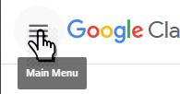

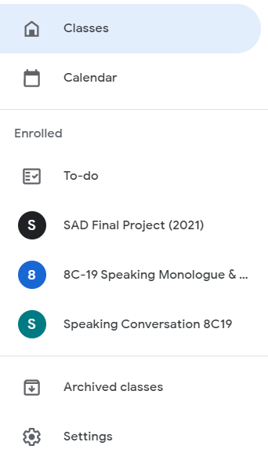

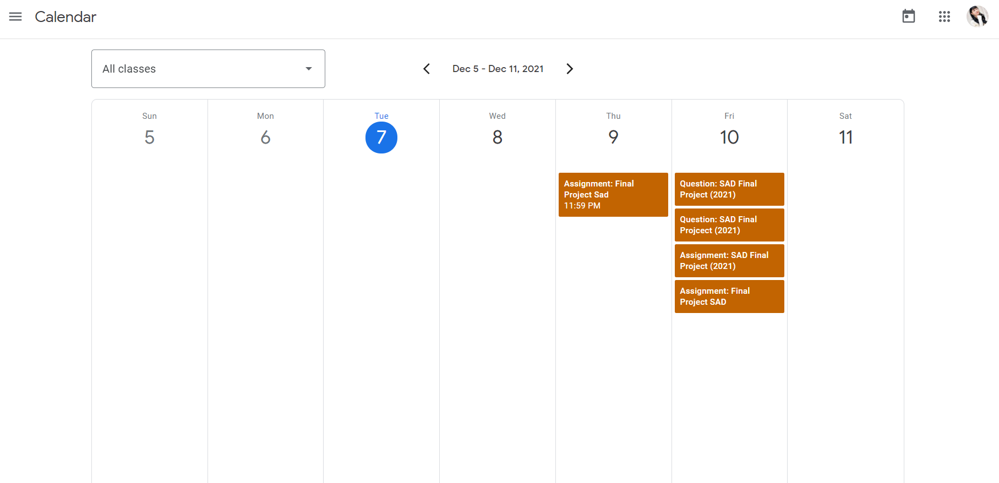

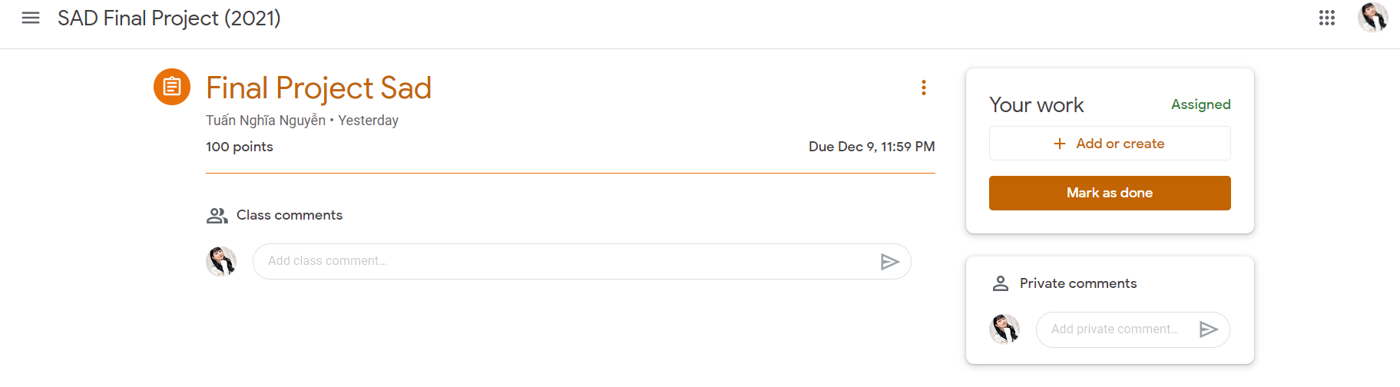

## Alternative Flows

None

# Special Requirements

## None

# Preconditions

Users must login successfully first!

# Postconditions

## None

# Extension Points

## None